**Requirements:**

Clients wants to create a Road Accident Dashboard for year 2021 and 2022 so that they can 5.8K have insight on the below requirements-  
  
❖ Primary KPI - Total Casualties and Total Accident values for Current Year and YoY growth  
  
❖ Primary KPI's - Total Casualties by Accident Severity for Current Year and YoY growth  
  
❖ Secondary KPI's - Total Casualties with respect to vehicle type for Current Year  
  
❖ Monthly trend showing comparison of casualties for Current Year and Previous Year  
  
❖ Casualties by Road Type for Current year 155804  
  
❖ Casualties by Light Condition  
  
❖ Current Year Casualties by Area/ Location & by Day/Night  
  
❖ Total Casualties and Total Accidents by Location

**Steps In Project**

1. Requirement Gathering
2. Stakeholders in Project
3. Raw data overview
4. Connecting data with Power BI
5. Data cleaning
6. Data processing
7. Data Modelling
8. Background Design in power point
9. Data visualization / Charts Design
10. Report / Dashboard building
11. Insights

**Data Validation**

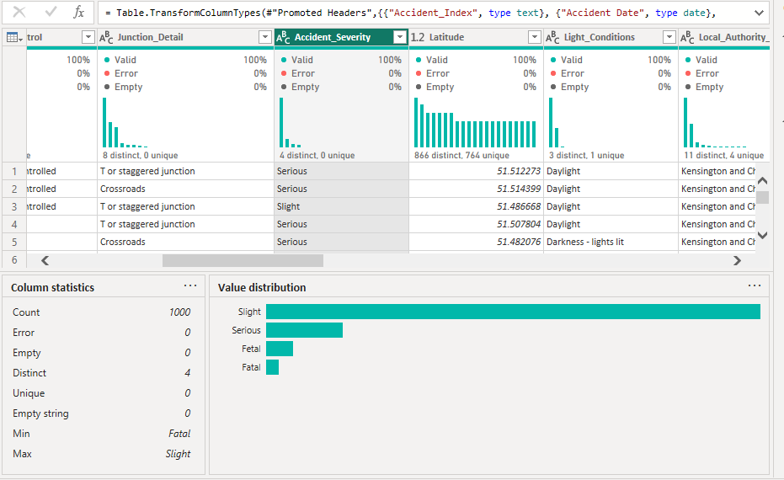

**Data Cleaning:**

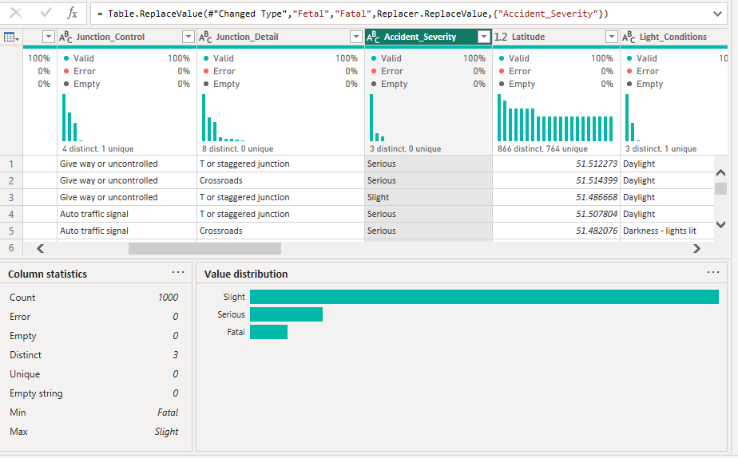

**Deliveries:**

URL:

<https://app.powerbi.com/view?r=eyJrIjoiZmMzMzNmNjItNzNiNS00NDFiLThjN2UtOGY5ZTIxM2I3ZWYyIiwidCI6ImRmODY3OWNkLWE4MGUtNDVkOC05OWFjLWM4M2VkN2ZmOTVhMCJ9>

